Waveshaper
A waveshaper distorts the shape of a waveform by applying some fixed function to each sample in the signal. It is a form of distortion and can introduce harmonics that were not there in the original signal. Waveshaping in the Web Audio API is implemented using the WaveshaperNode, which is the focus of this chapter. The theory of distortion is first given, since understanding how a given waveshaper affects a signal and changes the sound is key to effective use of this node. Then the node is introduced, along with its arguments, and special attention is paid to how an array is mapped to the waveshaping curve that is applied. Two source code examples are provided; a simple clipper, and a bit crusher to reduce the perceived bit depth in a signal.

Theory

Characteristic Curve
Most common audio effects are linear systems. In a linear system, if two inputs are added together and processed, the result is the same as processing each input individually and adding the results. And if an input is multiplied by a scalar value before processing, the result is the same as processing the input and then multiplying by that same scalar value. That is, for a linear audio effect, the following holds;
$$\begin{matrix}f\left(x_{1}\left[n\right]+x_{2}\left[n\right]\right)=f\left(x_{1}\left[n\right]\right)+f\left(x_{2}\left[n\right]\right) \\ f\left(ax\left[n\right]\right)=af\left(x\left[n\right]\right)\end{matrix}$$ | (12.1)
Distortion is a nonlinear effect for at least some input signals, meaning that Equation (12.1) does not hold. Waveshaping is a type of distortion largely described by a characteristic curve, a mathematical function relating the output sample y[n] to the input sample x[n]. The following equation is one of many possible characteristic curves to produce a distortion effect:
$$f(x)=\left\{\begin{matrix}2x \\ 1-(2-3x)^{2}/3 \\ 1\end{matrix}\right. \begin{matrix}0≤x<1/3 \\ 1/3≤x<2/3 \\ 2/3≤x≤1\end{matrix}$$ | (12.2)
In this example, for input samples with magnitude less than 1/3, the effect operates in a linear region, but as the magnitude of x increases, it becomes progressively more nonlinear until clipping occurs above x = 2/3 and the output no longer grows in magnitude. A plot is shown in Figure 12.1. This particular equation is best classified as an overdrive effect since it contains a linear and a nonlinear region with a gradual transition between them. It is the nonlinear region that will give this effect its distinct sound.
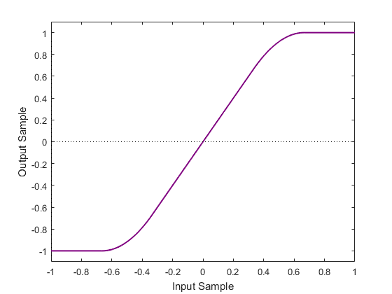
Figure 12.1. The characteristic input/output curve for a quadratic distortion.
The characteristic curve defines a memoryless effect: the current output sample y[n] depends only on the current input sample x[n] and not on any previous inputs or outputs. This is a reasonable approximation to how analog distortion circuits operate, though not an exact one as we will see in a later section. Distortion is also a time-invariant effect in that the output samples depend only on the input samples and not the time at which they are processed.

Hard and Soft Clipping
Both digital and analog systems have limits to the magnitude of signal they can process. For analog systems, these limits are typically determined by the power supply voltages and architecture of each amplifier stage. In digital systems, the limits are usually determined by the number of bits in the analog-to-digital converter (ADC) and digital-to-analog converter (DAC). When a signal exceeds these limits, clipping occurs, meaning that a further increase in input does not produce any further increase in output. Clipping is an essential feature of distortion effects, and the way that an effect approaches its clipping point is a crucial part of its sound.
Distortion effects are often classified by whether they produce hard clipping or soft clipping. Figure 12.2 compares the two forms. Hard clipping is characterized by an abrupt transition between unclipped and clipped regions of the waveform, which produces sharp corners in the waveform. Soft clipping is characterized by a smooth approach to the clipping level, creating rounded corners at the peaks of the waveform. In general, soft clipping produces a smoother, warmer sound where hard clipping produces a bright, harsh or buzzy sound. Hard versus soft clipping is not a binary decision, and any given characteristic curve will fall on a continuum between the two.
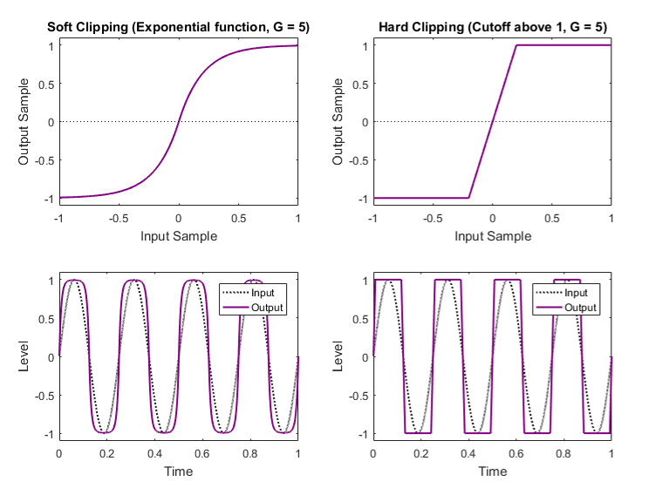
Figure 12.2. Comparison of hard and soft clipping.
The simplest, purest form of hard clipping simply caps the input signal above a certain magnitude threshold:
$f(x)=\left\{\begin{matrix}-1 \\ Gx \\ 1\end{matrix}\right. \begin{matrix}Gx≤-1 \\ -1<Gx<1 \\ Gx≥1\end{matrix}$, | (12.3)
where G is an input gain applied to x before comparing to the threshold, explained in the next section. Digital systems produce this result when overloaded. Musicians generally find it to be an unpleasant, overly harsh sound. In the analog domain, many amplifiers based on transistors produce hard clipping, and hard clipping can also be created in an effect pedal through the use of silicon diodes.
The characteristic curve in Equation (12.2) produces a form soft clipping since the transition from unclipped to clipped is gradual. The equation below [33] also produces soft clipping:
$f(x)=\operatorname{sgn}{(}x)(1-e^{-|Gx|})$. | (12.4)
In this equation, the output asymptotically approaches the clipping point as the input gets larger but never reaches it. The amount of distortion added to the sound increases smoothly as the input level increases. Soft clipping occurs in analog vacuum tube amplifiers and certain effects pedals based on germanium diodes. It is not a natural occurrence in digital systems unless deliberately created by a suitable characteristic curve.

Input Gain
The term G in Equations (12.3) and (12.4) is a gain term applied to the input signal x before it passes through the nonlinear function. Because distortion is a nonlinear effect, the gain (or amplitude) of the input signal changes how the effect sounds. For nearly all practical characteristic curves, higher gain produces more distortion in the output. Notice that applying more gain to the input signal does not substantially affect the amplitude of the output, since the clipping level remains in the same place.
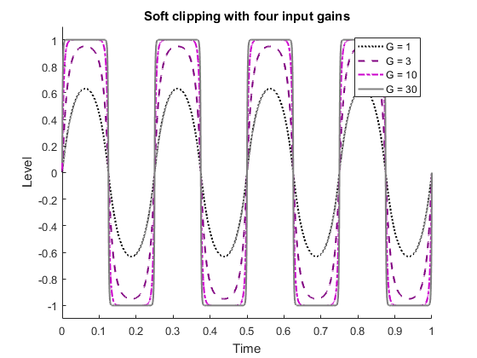
Figure 12.3. Soft clipping of a sine wave with four different input gains.
Figure 12.3 shows a sine wave subjected to soft clipping, Equation (12.4), with four different input gains. In the extreme case, the output approaches a square wave with amplitude equal to the clipping level. An extremely large input gain with a hard clipping effect would also produce an output approaching a square wave, showing that the differences between hard and soft clipping are less pronounced for very large gains.

Symmetry and Rectification
The equations presented in the preceding sections were all symmetrical in that they applied the same nonlinear function to the positive and negative halves of the waveform. Real analog guitar amplifiers, especially those based on vacuum tubes, do not always behave this way. Instead, the clipping point might differ for positive and negative half-waves, or the curve for each half-wave could be entirely different. Symmetrical and asymmetrical characteristic curves produce different effects in the frequency domain which are responsible for distinctive differences in sound.
Rectification is a special case of an asymmetrical function used in distortion effects. Rectification passes the positive half-wave unchanged but either omits or inverts the negative half-wave. It comes in two forms, shown in Figure 12.4. Half-wave rectification sets the negative half-wave to 0,
$f_{half}(x)=\max{(}x,0)$
Full-wave rectification, equivalent to the absolute value function, inverts the negative half-wave:
$f_{full}(x)=|x|$
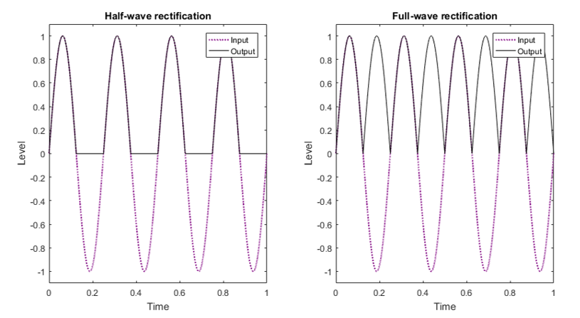
Figure 12.4. Half-wave and full-wave rectification.
Rectification is often combined with another nonlinear transfer function in a distortion effect. It adds a strong octave harmonic (twice the fundamental frequency) to the output signal. In the full-wave rectifier, the frequency of the waveform is twice the original since the negative half-waves have been inverted. The half-wave rectifier is equivalent to the average of the input and its full-wave rectified version, so also containing a strong octave harmonic.

Harmonic Distortion
The operation of a distortion effect is best understood as applying a nonlinear function to the input signal in the time domain. However, its characteristic sound comes from the artifacts the nonlinear function creates in the frequency domain. Linear effects have the property that while they may change the relative magnitudes and phases of frequency components in a signal, they cannot create new frequency components that did not exist in the original signal. By contrast, the nonlinear functions used in distortion effects produce new frequency components in the output according to two processes: harmonic distortion and intermodulation distortion.
Consider applying a distortion effect to a sine wave input with frequency f and sample rate f_{s}: x[n] = sin(2πf/f_{s}). A sine wave contains a single frequency component at f (Figure 12.5, left). The output of the effect may have a different magnitude and phase at f, but it may also contain energy at every multiple of f: 2f, 3f, 4f, etc. (Figure 12.5, right). These frequencies, which were not present in the input, are known as the harmonics of the fundamental frequency f, and the process that creates them is known as harmonic distortion. Every nonlinear function will introduce some amount of harmonic distortion. As a rough guideline, the more nonlinear the function, the greater the relative amplitude of the harmonics. Where multiple input frequencies are present, as in most real-world instrument signals, harmonics of each input frequency will appear in the output. In general, the magnitude of each harmonic decreases toward zero as frequency increases, but there is no frequency above which the magnitude of every harmonic is exactly zero. In other words, harmonic distortion will create infinitely many harmonic frequencies of the original input. This result can create problems with aliasing in digital implementations of distortion effects.
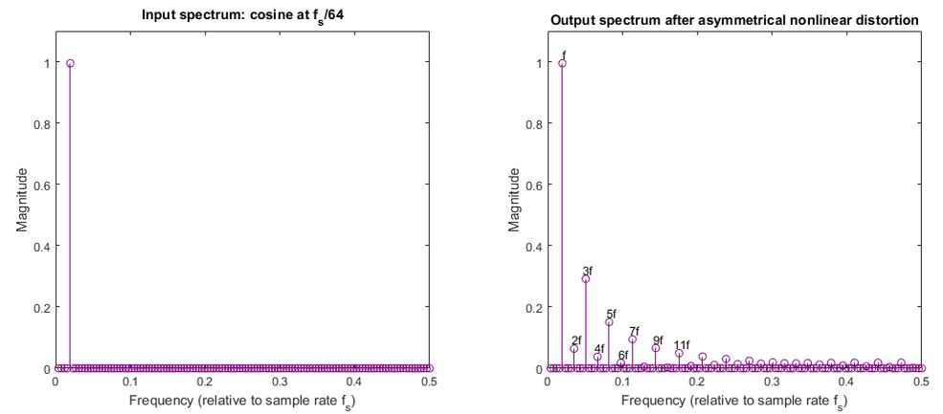
Figure 12.5. The spectrum of a single sine wave before and after asymmetric distortion has been applied.
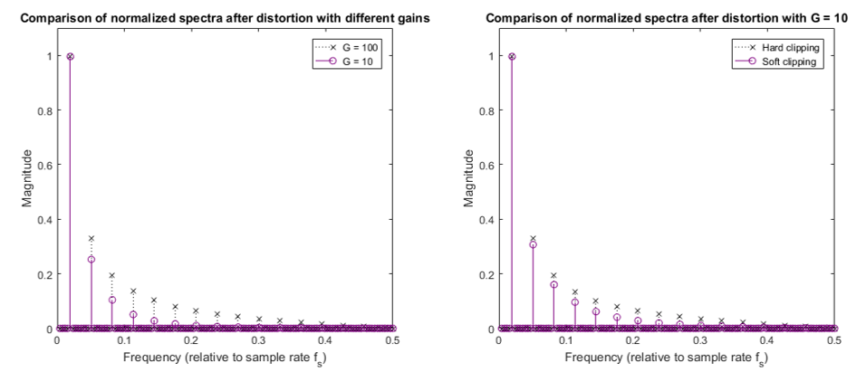
Figure 12.6. The output spectrum after distortion has been applied for sinusoidal input, comparing two values of distortion level for soft clipping (left), and comparing soft and hard clipping (right).

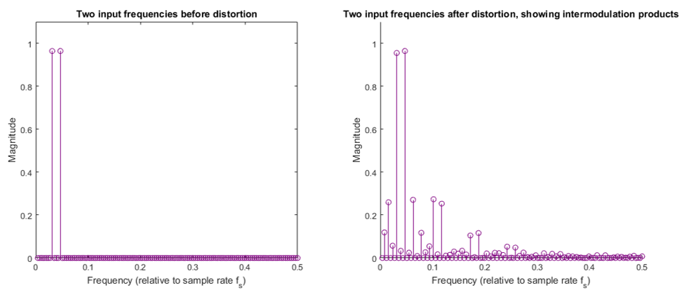
Figure 12.7. The spectrum of two sinusoids before and after distortion has been applied.
Detailed nonlinear analysis on the origins of harmonic distortion and its relation to specific characteristic curves are beyond the scope of this text, but in general, the more nonlinear the characteristic curve, the greater the magnitude of the harmonic distortion products that are introduced (Figure 12.6, left). Hard clipping also produces a different pattern of distortion products than soft clipping (Figure 12.6, right).
Another important relationship should be highlighted: odd symmetrical distortion functions produce only odd harmonics and even symmetrical distortion functions produce only even harmonics, where asymmetrical functions can produce both even and odd harmonics. Odd functions are those that obey the relationship f(–x) = –f(x), known as odd symmetry in mathematical terminology. Similarly, even functions obey the relationship f(–x) = f(x). For example, the hard clipping and full wave rectification given earlier are both symmetrical by this definition. For a fundamental frequency f, the odd harmonics are the odd multiples of f: 3f, 5f, 7f, etc. Similarly, the even harmonics are the even multiples of f: 2f, 4f, 6f, etc. The octave harmonic created by rectification is an even harmonic: 2f. Musicians often prefer the combination of both even and odd harmonics, and consequently asymmetrical functions are often preferred to symmetrical ones.
To see why an odd symmetrical function produces only odd harmonics, consider a sine wave input signal, x(t)=sin(ωt). Shifting the input signal by half a period (180°) is the same thing as inverting it, x(t+π/ω)=sin(ωt+π)= –sin(ωt)= –x(t).
As a consequence, for an odd function, adding the distorted outputs of the shifted and non-shifted sine waves will produce complete cancellation:
$f(x(t+π/ω))+f(x(t))=f(-x(t))+f(x(t)=-f(x(t))+f(x(t))=0$. | (12.5)
We have said that the output of the nonlinear function contains infinitely many harmonically-related sinusoids, so we can write it generically as:
$f(x(t))=\sum_{k=0}^{∞}{a_{k}\sin{(}kωt+ϕ_{k})}$. | (12.6)
where a_{k} are the magnitudes of each harmonic component and ø_{k} are the phases. Shifting the input by π/ω will shift the phase of every odd component (k = 1, 3, 5, ...) by π while leaving the even components (k = 0, 2, 4, 6, ...) unaltered:
$$f\left(x\left(t+π/ω\right)\right)=\sum_{k=0}^{∞}{a_{k}\sin{(}kωt+kπ+ϕ_{k})} \\ =\sum_{k=0}^{∞}{a_{k}(-1)^{k}\sin{(}kωt+ϕ_{k})}$$ | (12.7)

When the shifted and unshifted outputs, Equations (12.6) and (12.7) are added together, only the even harmonics remain in the expression,
$f(x(t))+f(x(t+π/ω))=\sum_{k=0}^{∞}{2a_{2k}\sin{(}2kωt+ϕ_{2k})}$.
However, Equation (12.5) showed that adding these two outputs together cancels to 0, which means that the even harmonics must be equal to 0. Therefore, an odd symmetrical function can produce only odd harmonics of the original input frequency. A similar argument can be used to show that even symmetrical functions only even harmonics. Creating both even and odd harmonics requires that the positive and negative half-waves be treated asymmetrically.

Intermodulation Distortion
Harmonic distortion is a desirable property of overdrive, distortion and fuzz effects. Another result, intermodulation distortion, is also a direct consequence of any nonlinear transfer function, but this result is generally undesirable in musical situations. Suppose the input signal contains two frequency components at f₁ and f₂:
$$x(t)=\sin{(}2πf_{1}t)+\sin{(}2πf_{2}t)$$
A general analysis of all nonlinear functions is beyond the scope of this text, but to see the mechanism behind intermodulation distortion, consider the simple nonlinear function f(x) = x²:
$f(x(t))=\sin^{2}{(}2πf_{1}t)+2\sin{(}2πf_{1}t)\sin{(}2πf_{2}t)+\sin^{2}{(}2πf_{2}t)$.
By trigonometric identity, the square terms produce an octave-doubling effect (twice the frequency):
$\sin^{2}{(}2πft)=[1-\cos{(}2π(2f)t)]/2$.
This property offers another way to understand the operation of the full-wave rectifier, which produces a similar (though not identical) output. However, it is the term in the middle, the product of two sines at different frequencies, which is responsible for the intermodulation distortion. Also by trigonometric identity:
$\sin{(}2πf_{1}t)\sin{(}2πf_{2}t)=[\cos{(}2π(f_{1}-f_{2})t)-\cos{(}2π(f_{1}+f_{2})t)]/2$.
The output will therefore contain sum and difference frequencies between the two frequency components at the input. Unless f₁ an f₂ are multiples of one another, these sum and difference frequencies will not be harmonically-related to either one (that is, not a multiple of either f₁ or f₂). This in turn means that these new frequencies will sound discordant and often unpleasant. This intermodulation process happens with every pair of frequencies in the input signal, so the more complex the input, the greater the number and spread of intermodulation products. An example of intermodulation distortion is shown in Figure 12.7.
Highly nonlinear characteristic curves such as those found in fuzz effects will have a higher amplitude of intermodulation products, just as they produce higher amplitudes of harmonic distortion. This is the reason that single notes and “power chords” (combinations of octaves and perfect fifths) often work best with fuzz boxes: these inputs typically contain only harmonically-related frequencies so all the intermodulation products remain harmonic. Unfortunately, we cannot choose only harmonic distortion products without intermodulation; the right type of distortion effect must be chosen for each musical application which balances these two qualities.

Aliasing and Oversampling
The nonlinear functions used in distortion create an infinite number of harmonics, frequency components which are integer multiples of an original frequency in the input signal. In the digital domain, the unbounded series of harmonics creates a problem with aliasing. Harmonics that are above the Nyquist frequency will be aliased, appearing in the output as lower-frequency components (Figure 12.8a). The aliased components are no longer harmonically-related to the original sound, nor can they be filtered out once they appear. Unless aliasing is avoided, the quality of digital distortion effects will suffer compared to their analog counterparts.
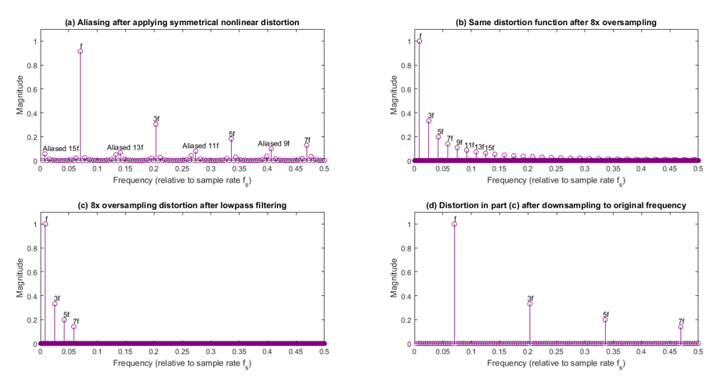
Figure 12.8. Output spectrum with aliasing due to distortion, and the output spectrum after oversampling, low pass filtering and downsampling.
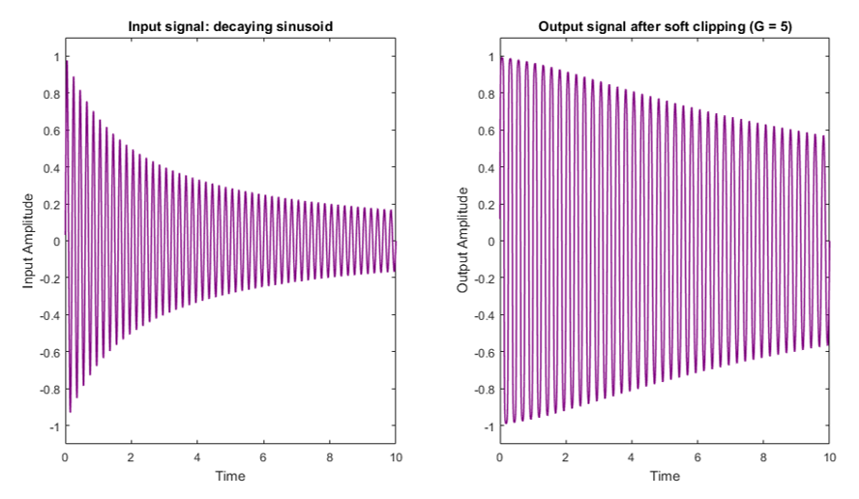
Figure 12.9. The effect of soft clipping on a decaying sinusoid.
The best way to reduce aliasing in a distortion effect is to employ oversampling. Prior to applying the nonlinear function, the input signal is upsampled to several times the original sampling frequency. Oversampling by a factor of N can be accomplished by inserting N-1 zeroes between each input sample. This signal is then filtered to remove frequencies above the original Nyquist frequency (Figure 12.8b-c).
Once the signal has been upsampled, the nonlinear characteristic curve can be applied. This will still generate an infinite series of harmonic products, but now considerably more of them will fit within the new, higher Nyquist frequency. Furthermore, even though aliasing still occurs, the first aliased components are still in the higher frequency regions above the original Nyquist frequency. Since the harmonic distortion components decrease in amplitude with increasing frequency, those components that are aliased back into the audible range will be greatly reduced in amplitude (Figure 12.8d).
After the nonlinear curve is applied, the signal is again filtered to remove frequencies above the original Nyquist frequency. The signal is then downsampled back to the original rate. Downsampling by a factor of N can be accomplished by choosing every N^{th} sample and discarding the rest.
Even when aliasing is minimized, distortion effects can produce a large number of new frequency components extending all the way to the top of the human hearing range. In some cases, these high-frequency components create an undesirable harshness in the output. For this reason, some distortion effects incorporate a lowpass or shelving filter after the nonlinear function to reduce the magnitude of the high-frequency components. First order filters are often used to create a gentle rolloff in the upper frequencies. The corner frequency of this filter or, in the case of the shelving filter, the gain, may be a user-adjustable control.
Other distortion effects incorporate a lowpass filter before the nonlinear function. The purpose of this arrangement is to reduce the magnitude of high-frequency components in the input signal, which reduces their contribution to intermodulation distortion.

Common Parameters
The characteristic curve of a distortion effect is typically fixed by design. Simple digital distortion effects generally follow analog effects in having a single curve; however, sophisticated multi-effects units may let the user choose from a range of options to simulate different classic analog sounds.
The input gain (or just gain) is a user-adjustable parameter on most effects. This control changes the gain of the input signal before it passes through the nonlinear transfer function. Implementation is simply a matter of multiplying the input sample by a constant before putting it into the nonlinear function. A higher gain produces a more distorted sound.
Since a large input gain is usually required to produce a heavily distorted sound, the output of the nonlinear function might be much higher in level than the input. Thus most distortion effects produce an output which is consistently near the clipping level. Thus it can be useful to incorporate a post-effect volume (or output gain) control which scales the level of the output to more closely match the input. This is accomplished by multiplying the output of the nonlinear function by a constant, which typically ranges from 0 (muted) to 1 (full volume). In a purely linear effect such as a filter or delay, the gain and volume controls would produce the same result, since it does not matter whether a scaling operation takes place before or after a linear effect. In the distortion effects, the two controls have different results, so it is useful to include them both in a practical effect.
Some effects also feature a tone control which affects the timbre or brightness of the output. This control can be implemented in several ways, but it typically involves a low pass filter placed before or after the nonlinear transfer function. The control can affect the cut-off frequency of the filter or, if a low shelving filter is used, the shelf gain. Placing a low pass filter before the nonlinear function can help reduce intermodulation distortion by eliminating high frequency components from the input signal. Placing a low pass filter after the nonlinear function will attenuate the resulting high-frequency distortion products.

Tube-sound Distortion
Guitarists often seek digital alternatives which recreate the sound of classic vacuum tube amplifiers. Emulation techniques are often mathematically complex, but the following choices in a basic distortion effect will help approach a tube-like sound:
- Use a soft clipping characteristic curve which rounds the corners of the waveform as it approaches the clipping level.
- Choose the curve to be at least mildly asymmetrical, which will produce even and odd harmonics. For example, the top and bottom half-waves in Equation (12.4) could use a different input gain.
- Use oversampling to control non-harmonic products from aliasing. If the sound is still too harsh, consider adding a gentle low pass filter before or after the nonlinear function.

WaveshaperNode
In its basic form, where waveshaping is memoryless and just given by a simple input-output equation. Then, it is among the simplest effects to implement. It can be calculated on a sample-by-sample basis by applying the nonlinear function to each input sample. However, waveshaping, even when memoryless, is not easily given by a simple equation. And as a node in an audio graph, it needs to be flexible enough to work with almost any reasonable input-output curve.
The WaveShaperNode interface represents a nonlinear distorter. It uses a curve to apply a wave shaping distortion to the signal. Beside obvious distortion effects, it is often used to add a warm feeling to the signal. Arbitrary nonlinear shaping curves may be specified.
A WaveShaperNode always has exactly one input and one output. The number of output channels always equals the number of input channels. The waveshaper takes a shaping curve and an optional oversample attribute.
The curve property of the WaveShaperNode is a Float32Array of length at least 2. It describes the distortion function to apply. Indices of the curve correspond to equally spaced x values from -1 to +1. Any sample value less than -1 will map to the first value in the curve array, and any sample value greater than +1 will correspond to the last value in the curve array. Intermediate values of the distortion curve that fall between index values are linearly interpolated.
If the curve attribute is null, the node simply passes its input to its output without modification.
Suppose we have an array C of N elements containing the curve approximating some function y=f(x). So C[0] represents the value at -1, C[N-1] the value at +1, and C[n] the value at 2n/(N-1) -1. We can restate this as a function x(n)= 2n/(N-1)-1, or n(x)=(x+1)(N-1)/2 to see how locations map to indices. However, since x is continuous, n can assume a fractional value between two actual indices.
Now, what is the output y of the waveshaping node for a given input sample x? Remembering that values between indices are interpolated, we need to find out how far n is between two vertices. This is just given by $n-\left\lfloor n\right\rfloor$, where $\left\lfloor n\right\rfloor$ denotes the highest integer less than or equal to n. This then weights how much the array elements C[n] and C[n+1] contribute to the actual sample value for an input lying between the corresponding x values.
We can write this formally as follows. The curve values are given by,
$$C\left[n\right]=f\left(2n/\left(N-1\right)-1\right)$$
And if we define
$$n_{x}≡\frac{N-1}{2}\left(x+1\right),and n_{L}≡\left\lfloor n_{x}\right\rfloor$$
Then a sample x will give an output of the waveshaper node as
$$y=\left\{\begin{matrix}C[0] & x<-1 \\ C[N-1] & x≥1 \\ \left(1-n_{x}+n_{L}\right) C[n_{L}]+\left(n_{x}-n_{L}\right) C[n_{L}+1] & \text{otherwise}\end{matrix}\right.$$
This is illustrated in Figure 12.10 for a curve array with six elements, where the original function is f(x)=x²sgn(x).

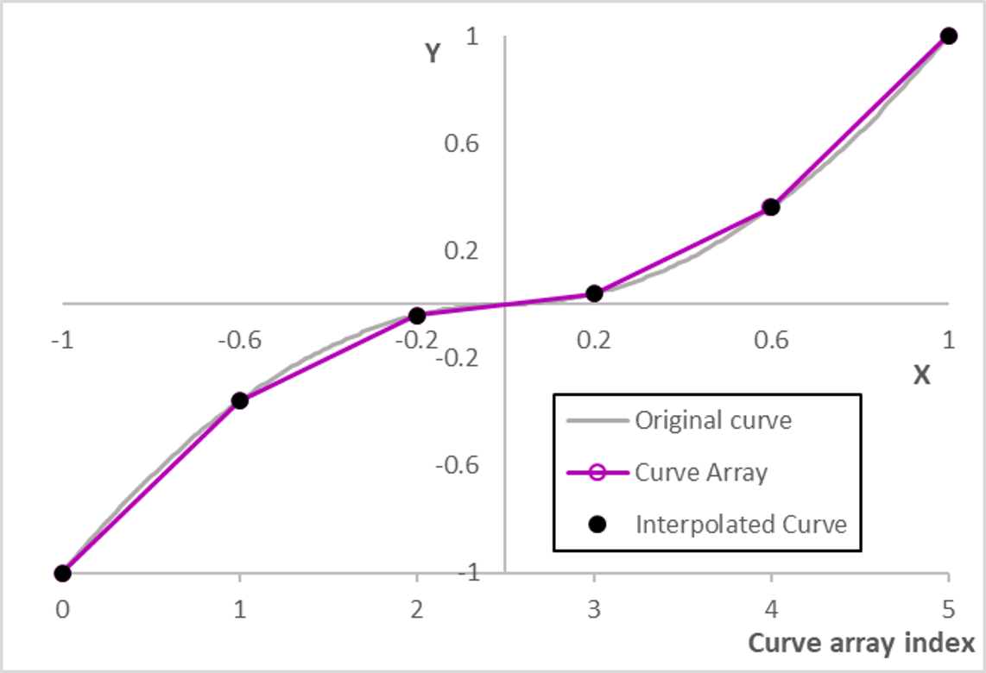
Figure 12.10. How the waveshaping curve is used. For an original curve over the interval -1 to +1, equally spaced values are mapped to an array with indices 0 to N-1, and waveshaping outputs are interpolated between the array values.
The oversample parameter is the type of oversampling to use for the shaping curve. It can be one of three values. The default value is 'none', meaning the curve will be applied directly to the input samples. A value of '2x' or '4x' means that the input samples are up-sampled to 2 or 4 times the sample rate of the AudioContext, then the shaping curve is applied, then the data is downsampled back to the AudioContext’s sample rate. The exact up-sampling and down-sampling filters are not specified.
Oversampling can improve the quality of the processing by avoiding some aliasing, with the '4x' value yielding the highest quality. But for many applications it is not needed, or the aliasing may be intended. And use of oversampling introduces some additional processing and latency.

Example – clipping a signal
Code example 12.1 shows clipping implemented with the waveshaper node. The interesting lines are those that generate the curve parameter of the waveshaper. The curve contains one hundred uniformly spaced samples, such that sample 0 is mapped to x=-1 and sample 99 mapped to x=+1. When x is above the positive Threshold, the curve[i] is set to that threshold. And for any x value below –Threshold, the curve is set to –Threshold. Values in between are unchanged.
The threshold ranges between 0 and 1. Note that, the lower the Threshold, the more clipping is applied. When the threshold is set to 0, the output is a constant 0, so silence.
<button id='Start' onclick='context.resume()'>start</button>
<p>Clipping Threshold</p>
<input type='range' max=1 step='any' value='1' id='Threshold'>
<script>
var context = new AudioContext()
var source = new OscillatorNode(context)
var clipper = new WaveShaperNode(context)
source.connect(clipper).connect(context.destination)
source.start()
Threshold.oninput = function() {
var x,nSamples = 100,curve = new Float32Array(nSamples)
for (let i=0;i<nSamples;++i) {
x = 2*i/nSamples-1 // x goes from -1 to +1
if (Math.abs(x)>this.value) curve[i]=this.value*Math.sign(x)
else curve[i]=x
}
clipper.curve=curve
}
</script>
Code example 12.1. Clipper.html, showing how to clip a signal with the WaveShaperNode.

Example – The Bit Crusher
Code example 12.2 shows a simple bit crusher. A bit crusher is an audio effect that reduces the resolution and sample rate of a signal, though in this case we only reduce the resolution by simulating bit depth reduction.
Internally, the Web Audio API encodes audio with Float32, which has 24 bits of precision for numbers between -1 and +1. But we only consider lowering bit depth bellow 16 bits. We simulate bit crushing by quantizing the input to L=2^{b} equally spaced levels, placed at the midpoints of equally spaced regions covering the range between –1 and +1, where b represents bit depth. So for b=1, inputs between $-$1 and 0 get quantized to -0.5, and inputs between 0 and +1 get quantized to +0.5.
The levels are located at $(2l+1)/L-1 for l=0,1,.. .L-1.$
To implement this with the waveshaper curve, we need the array of samples to map to the quantization levels. So we first map the samples $n=0,1,.. .N-1$ to x$=L·n/N$. We then apply the Math.floor() function which returns the largest integer less than or equal to a given number. Finally, we map these l values to $(2l+1)/L-1$, so that we now have the appropriate waveshaper curve.
Suppose we have 16 samples in the waveshaping curve array and the bit depth is 3. So we will quantise audio to 2³=8 levels. First, the indices n=0, 1,… 15, 16 of the array would map to values x[n]$=8·n/16$, giving 0, 0.5, 1, … 7, 7.5. The 16 samples are now quantized to the integer levels from 0 to 7, giving 0, 0, 1, 1, … 7, 7. These x values are then mapped to the desired quantisation levels using y=(2x+1)/8-1. The resultant input/output curve is given in Figure 12.11.
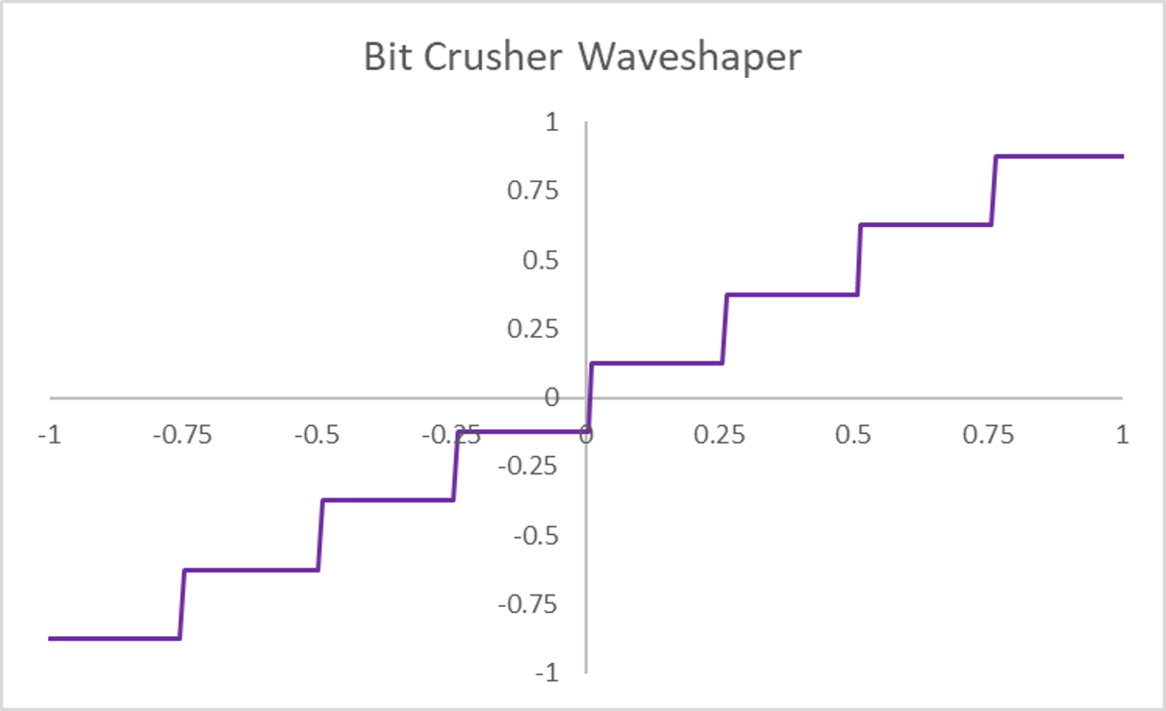
Figure 12.11. The input/output curve for a bitcrusher with bit depth = 3 (8 levels).
<button id='Start' onclick='context.resume()'>start</button>
<p>Bit depth</p>
<input type='range' min=1 max=4 value=3 step=1 id='nBits'><br>
<script>
var context = new AudioContext()
var source = new OscillatorNode(context)
var bitCrusher = new WaveShaperNode(context)
source.connect(bitCrusher).connect(context.destination)
source.start()
nBits.oninput = () => {
var x,nSamples = 65536,curve = new Float32Array(nSamples)
var nLevels=Math.pow(2,nBits.value)
for (n=0;n<nSamples;++n) {
x = n*nLevels/nSamples
y = Math.floor(x)
curve[n] = (2*y+1)/nLevels-1
}
bitCrusher.curve=curve
}
</script>

Code example 12.2. BitCrusher.html, using the WaveShaperNode to quantize a signal.

The expression sgn(x) takes the value 1 for x >= 0, -1 otherwise.

